Project Name: Budget versus actual
Some Remarks on the tables provided:
- Budget granularity is monthly. The table is not in a standard tabular form and should be unpivoted.
- Actual granularity is daily. And the table is in a standard tabular form.
After inspecting the provided datasets, we have discovered the need to add two dimensions: dCalendar, dProduct
Steps:
1- Power Query
- Load both Budget and actual tables from the Excel Data Source.
- Change the tables names according to the data model standards (fAcual, fBudget)
- Unpivot the Budget table around the product through 'Unpivot only selected columns'
- Adjust the data types of both tables.
- Create a Product table from the budget file by referencing budget table.
- in the referenced budget table, select product column and remove other columns. Then remove the duplicates.
- Close and apply to quit Power Query.

2- Table View
- Go to Table view and select New Table and use the following DAX formula to generate the dCalendar table:
dCalendar = CALENDARAUTO()
- Add the following columns to the dCalendar table:
- Year --> Year = YEAR(dCalendar[Date])
- Month name --> Month = FORMAT(dCalendar[Date], "MMM")
- Month # --> Month # = FORMAT(dCalendar[Date], "MM")
- Quarter # --> Quarter # = FORMAT(dCalendar[Date], "Q")
- Quarter --> Quarter = CONCATENATE( "Q", dCalendar[Quarter #])
- End of Month --> End Of Month = EOMONTH(dCalendar[Date], 0)
- Adjust the data formats before quitting table view.

3- Model View
- Go to Model View and establish the relationship among the four tables as shown below:
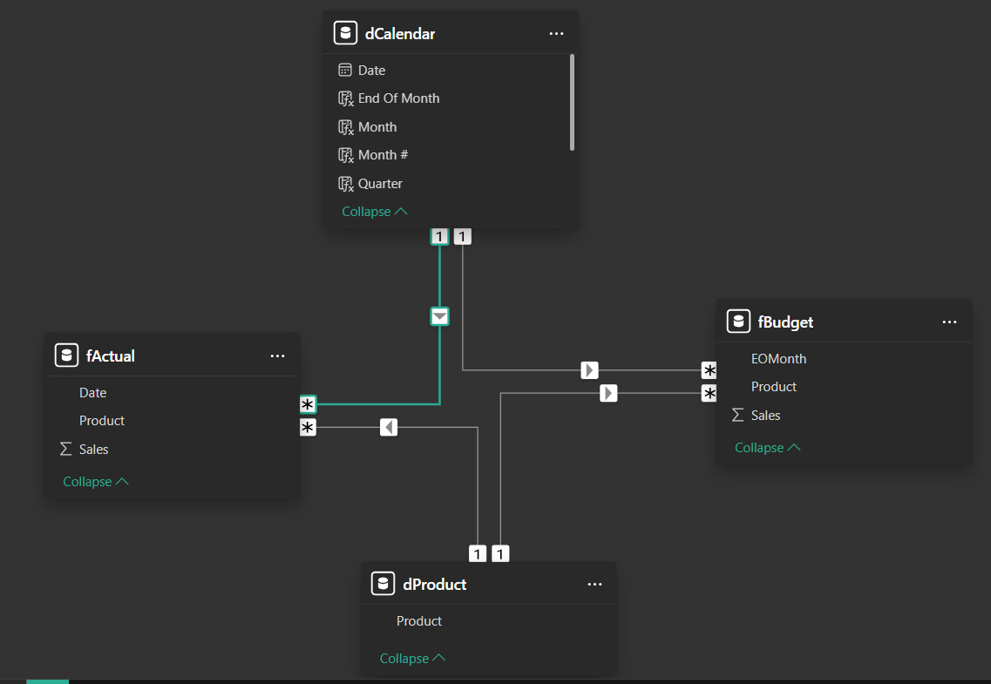
- Hide the foreign keys in both fact tables.
- Create a new table named _measures to host all DAX measures using the formula _Measures =
- Build the following DAX measures:


